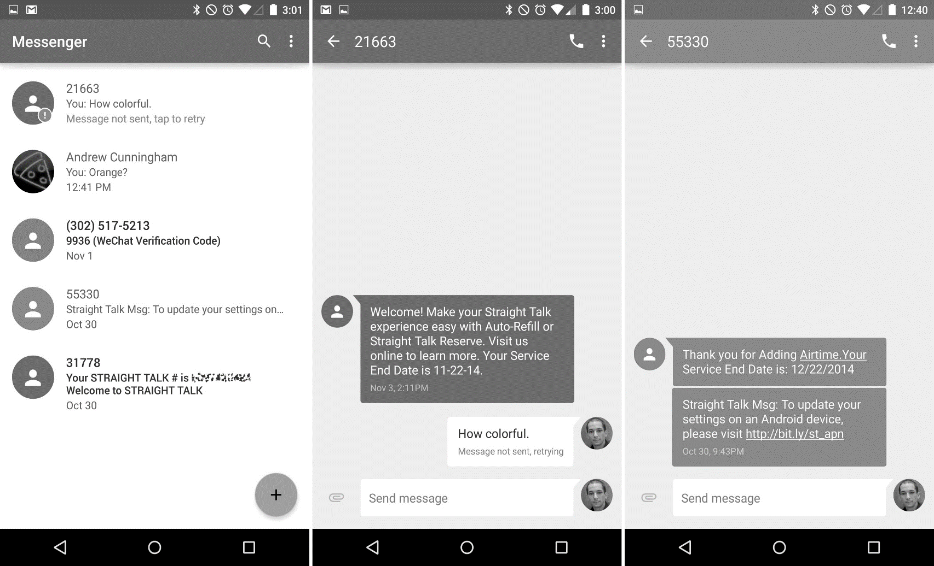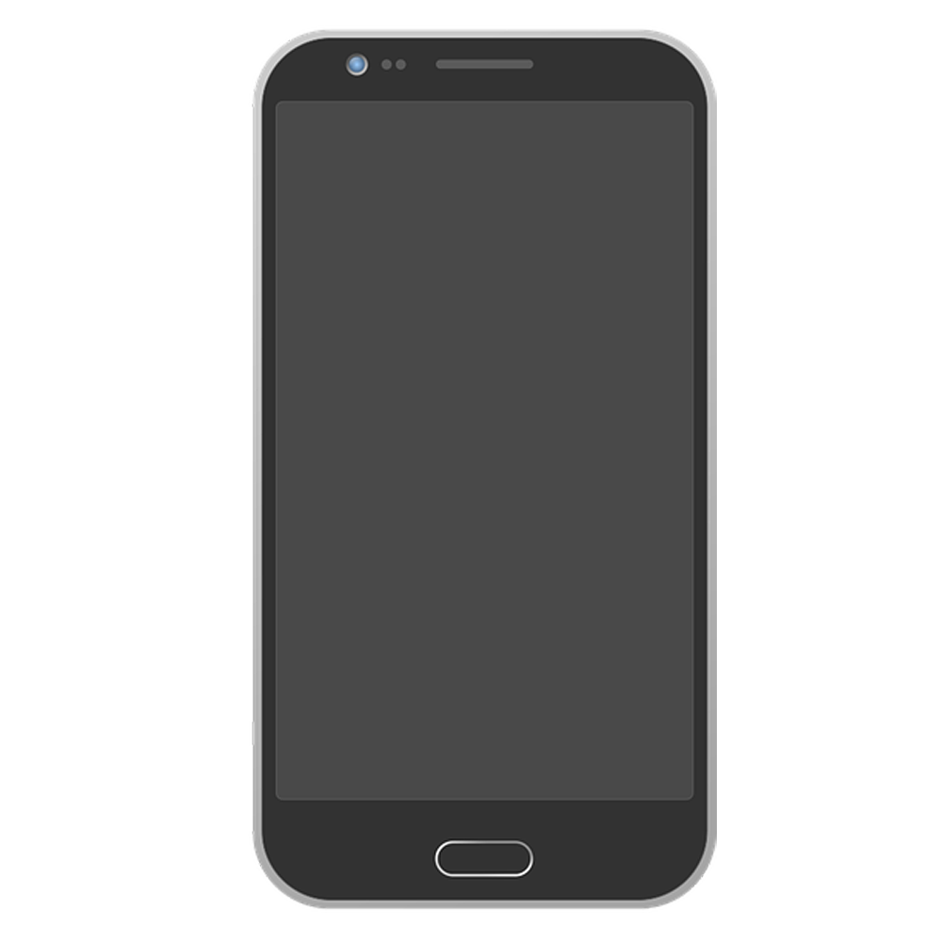

**Log In**

Emoji Checker

Email Address

Phone Number

Username

Password

Name

Choose Emoji



**Create Account**

**Create an Account**

**Sign Up**



Password

Username

**Log In**

**Submit**





**+ Account Settings**

**+ Query**

**+ View Previous Emojis**

**Storm Simpson**



**Add a Class**



Vibes?



**Query**

**Submit**

Days

Time

Course Name

**Add**



* Class: Software Engineering
* Date: September 20, 2018
* Time: 5:45 PM
* Class: Software Engineering
* Date: September 18, 2018
* Time: 6:30 PM
* Class: Software Engineering
* Date: September 13, 2018
* Time: 6:00 PM
* Class: Software Engineering
* Date: September 11, 2018
* Time: 6:15 PM
* Class: Software Engineering
* Date: September 6, 2018
* Time: 5:45 PM

Thank you for selecting an emoji! Your response has been recorded.

**Response Confirmation**



**View Previous Emojis**



**Submit**

**<**

**Change Password**

New Password

Reenter Password

Current Password



**Save Changes**

Email Address

Phone Number

Change Password >

Name

**Account Settings**

